**PROJECT ERROR CONTROL**

**Group 2**

Rahul Rachamalla

Naresh Kumar Kudithi

Abhilash Reddy Tathireddy

Vamsikrishna Naidu Pattabhe

**PROCOTOL DESIGN**

Packet size: 1024 Bytes

Header Size: 4 Bytes

Source Port: 2 Bytes

Destination Port: 2Bytes

Pay load size: 1020 Bytes

Window size for GBN = 5 (Default is 3)

Timeout = 1500ms (May be different for others)

Packet losses can be manually inputted anything between 1 to 99 percentage.

**STOP AND WAIT:**

Stop and wait protocol is a technique which provides data transmission through unreliable packet delivery system. In normal operation one packet is transmitted and the sender waits for acknowledgment and during Timeout if the sender doesn’t receive the ACK from the receiver then the sender waits for a specific period of time and then retransmits again. That is the main Idea.

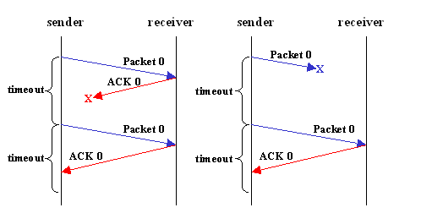

**Go Back N**

In Go back N protocol, the sender has to buffer all unacknowledged packets, because they may require retransmission. Receiver may be able to accept out-of-order packets, but only up to its buffer limits. The sender needs to set timers in order to know when to retransmit a packet that may have been lost. It allows multiple packets to be transmitted at the same time so that the system/line is not idle for long amount of time and accepts packets in proper order.

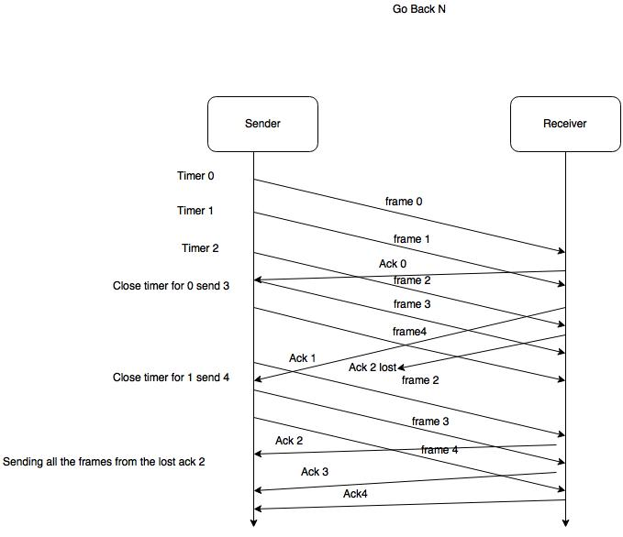

**Reference:**

1. Stallings, William. Data and Computer Communications. Upper Saddle River, NJ: Prentice Hall, 2014. Print.
2. Forouzan , Data Communications and Networking Fourth Edition.